**­CSC 1101 – Problem Solving and Programming Laboratory – Winter 2019**

**Lab 11 – (student name)**

**25 points – Due February 26, end-of-class**

**a)** Save this document with your name and the lab assignment number somewhere in the file name.

**b)** Type/paste your answers into the document.

c) Submit this document and your .cpp file(s) to the Canvas item where you downloaded this document. Do not submit a zip file but individually attach your files.

Create a copy of the C++ template file. Write a C++ console application and do the following:

1. Rename the copy you made to **yourName_InClass_Lab11.cpp** and save it into your *CSC1101* folder.
2. Complete the header comment.
3. Modify the application header and close to contain the application name.
4. Prompt the user for two positive integer numbers (*num1, num2*) and use a validation loop to check that the values are between [-50, 50].
5. Using **if/else if/else** statements, check for and do the following:
   1. If *num1* is greater, use a **while** loop to increase the value of *num2* by 5 until it is the same as or greater than *num1* and output your results separated by a space;
   2. If *num2* is greater, use a **for** loop and initialize the counter variable *i* to *num1*. Increment *i* by two units until it reaches *num2* and output your results separated by a space;
   3. If they are the same number, output a message to the console stating they are the same as well as the value stored in *num1* and *num2*.
6. Run the program three times for each condition and take a screenshot of each one.

*[your program code here]\**

**//==========================================================**

**//**

**// Title: Equalizer**

**// Course: CSC 1101**

**// Lab Number: Lab 11**

**// Author: Trevor Trusty**

**// Date: 2/26/2019**

**// Description:**

**// Makes numbers that aren't equal closer to equal or something.**

**//**

**//==========================================================**

**#include <conio.h> // For function getch()**

**#include <cstdlib> // For several general-purpose functions**

**#include <fstream> // For file handling**

**#include <iomanip> // For formatted output**

**#include <iostream> // For cin, cout, and system**

**#include <string> // For string data type**

**using namespace std; // So "std::cout" may be abbreviated to "cout"**

**int main()**

**{**

**int num1, num2;**

**// Show application header**

**cout << "Welcome to Equalizer!" << endl;**

**cout << "--------------------------" << endl << endl;**

**//Prompt for first number**

**cout << "Enter a positive integer: " << endl;**

**cin >> num1;**

**//Validation loop**

**while (num1 > 50 || num1 < -50)**

**{**

**cout << "Error num1" << endl;**

**cout << "Enter a positive integer: " << endl;**

**cin >> num1;**

**}**

**//Prompt for second number**

**cout << "Enter a positive integer: " << endl;**

**cin >> num2;**

**//Validation loop**

**while (num2 > 50 || num2 < -50)**

**{**

**cout << "Error num2" << endl;**

**cout << "Enter a positive integer: " << endl;**

**cin >> num2;**

**}**

**//Test if number 1 is bigger**

**if (num1 > num2)**

**{**

**cout << "First number greater than second number.\n";**

**while (num1 > num2)**

**{**

**int x = 1;**

**num2 += 5;**

**cout << num2 << ' ';**

**}**

**}**

**else if (num2 > num1)**

**{**

**cout << "Second number greater than first number.\n";**

**for (int i = num1; i < num2; i+=2)**

**{**

**cout << i << ' ';**

**num1 = i;**

**}**

**}**

**else**

**{**

**cout << "Both numbers are equal." << endl;**

**cout << "Num1 = " << num1 << endl;**

**cout << "Num2 = " << num2;**

**}**

**// Show application close**

**cout << "\n\nEnd of my Equalizer" << endl << endl;**

**// Pause before application window closes**

**cout << "Press any key to exit ..." << endl;**

**_getch();**

**}**

*[your program output here]\*\**

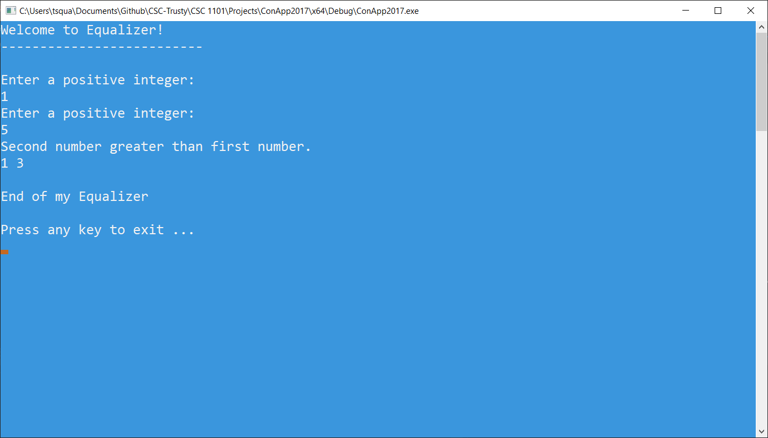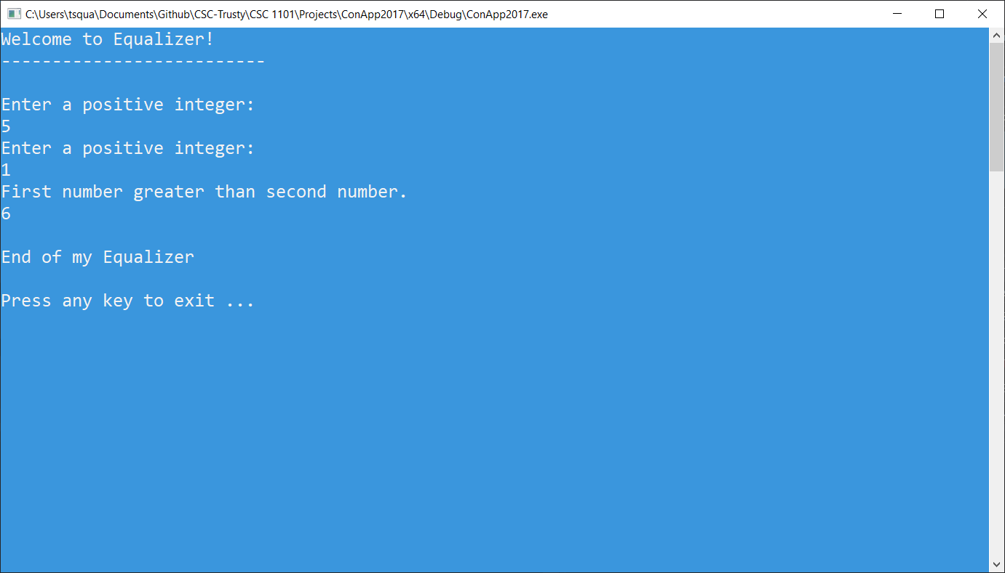

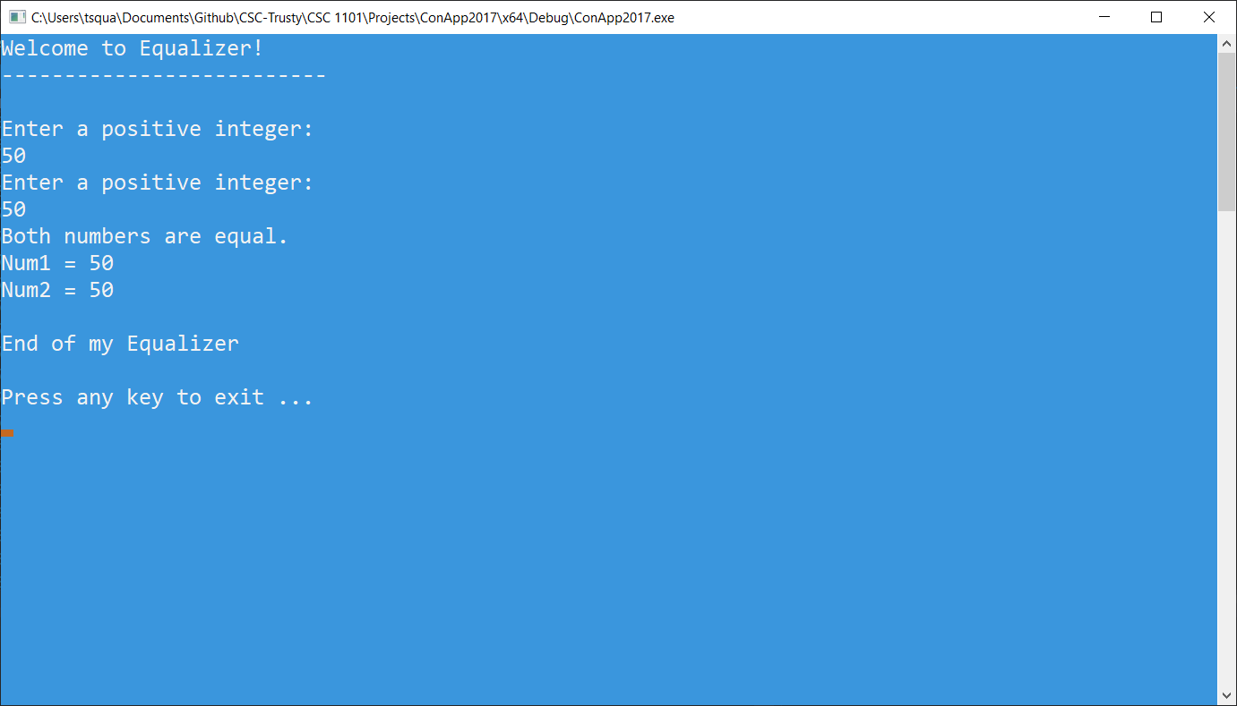

* **Copying-and-pasting Visual C++ code to a Word document**

1) From within the Visual C++ program, press **CTRL-A** and press **CTRL-C**.

2) From within the Word document, press **CTRL-V**.

** **Copying-and-pasting Visual C++ console application output to a Word document**

1) From the Visual C++ console, press **ALT-PrintScreen**.

2) From within the Word document, press **CTRL-V**.